ARCHITECTURE DOCUMENT
Project: Session Integrity Firewall (SIF)
Continuous Application-Layer Session Protection System

1. Application Architecture
Selected Architecture
Microservices-Oriented Middleware Architecture
1.1 Architectural Overview
The Session Integrity Firewall (SIF) is designed as a middleware security layer positioned between the Client Layer and the Backend Application Layer.
High-Level Flow (As per Diagram)
Client Layer
→ HTTP/HTTPS Request
→ Session Integrity Firewall (SIF)
→ Backend Application Layer (Only if allowed)
→ Database Layer
SIF logs all validation events into a separate Security Database.

2. Exploration of Design Alternatives
To implement continuous session validation and risk-based enforcement, multiple architectural approaches were evaluated before selecting the most suitable design.

2.1 Monolithic Architecture
Description
All session validation, risk evaluation, enforcement, and logging components are integrated into a single application.
Advantages
- Simple development and deployment
- Low communication overhead
- Easier debugging in early stages

Limitations
- Difficult to scale individual security modules
- Tight coupling reduces flexibility
- Hard to integrate future AI-based risk engines
- Single point of failure
Conclusion: Not suitable for scalable and extensible security middleware.

2.2 Serverless Architecture
Description
Session validation and risk analysis functions are implemented as cloud-based serverless functions triggered on each request.
Advantages
- Automatic scaling
- Cost-efficient for low traffic
- Minimal infrastructure management
Limitations
- Cold start latency affecting real-time validation
- Difficult state management for session tracking
- Vendor lock-in risk
- Complex debugging and monitoring
Conclusion: Not ideal for continuous stateful session monitoring.

2.3 Event-Driven Architecture
Description
Session events trigger asynchronous processing via message queues for risk evaluation and logging.
Advantages
- High scalability
- Loose coupling between modules
- Efficient asynchronous processing
Limitations
- Added complexity in event orchestration
- Delayed enforcement decisions
- Overhead in managing message brokers
Conclusion: Suitable for logging and analytics but less effective for real-time enforcement.

2.4 Microservices-Oriented Middleware Architecture (Selected)
Description
Session Integrity Firewall operates as modular middleware between client and backend, with independent services for validation, risk scoring, enforcement, and logging.
Advantages
- Independent scaling of security modules
- High modularity and maintainability
- Real-time enforcement capability
- Easy integration with existing authentication systems
- Supports future AI-based risk engine replacement
Limitations
- Slight communication overhead
- Requires proper service orchestration
Conclusion: Best suited for continuous session validation due to modularity, scalability, and extensibility.

Final Architecture Selection
Based on comparative analysis, a Microservices-Oriented Middleware Architecture was selected as it provides real-time validation, modular design, independent scalability, and seamless integration with existing web applications while enabling future AI-driven enhancements.

3. Layered Architecture Description
3.1 Client Layer
Component:
- Client (Browser / API Client)
Responsibilities:
- Sends HTTP/HTTPS requests
- Carries session token (JWT / Session ID)
- Interacts with protected backend APIs

3.2 Session Integrity Firewall (SIF) – Microservices-Oriented Middleware
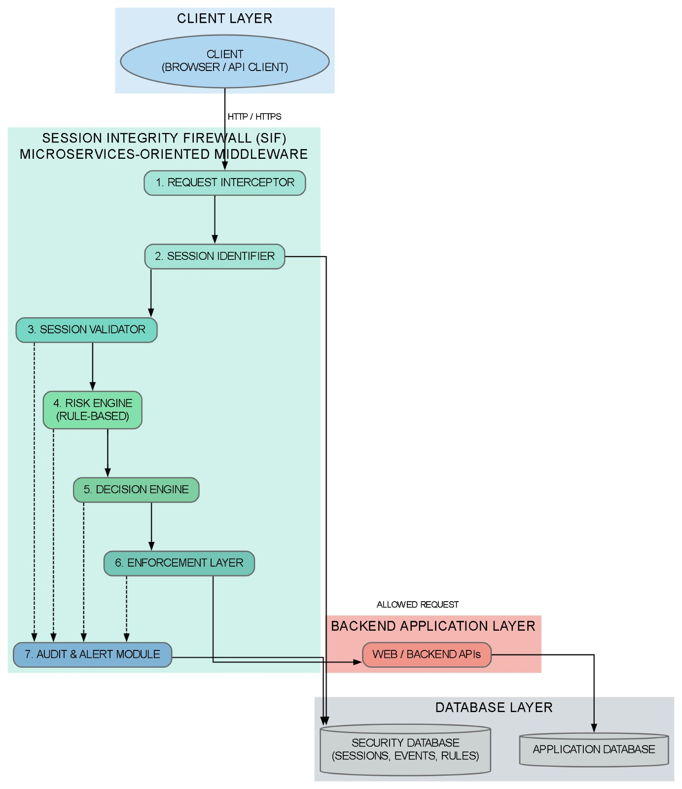
1. Request Interceptor
- Entry point of SIF
- Captures all incoming requests
- Extracts:
  - Headers
  - IP address
  - User-Agent
  - Session token
- Forwards metadata to Session Identifier
2. Session Identifier
- Extracts Session ID or JWT
- Maps request to corresponding session record in the Security Database
- If no session found → triggers risk escalation
3. Session Validator
Validates session against stored metadata:
- IP address verification
- Device fingerprint comparison
- Geo-location validation
- Session status check (Active / Terminated)
- Expiry verification
If mismatch detected → forwards to Risk Engine
4. Risk Engine (Rule-Based)
- Applies deterministic security rules stored in security_rules table
- Computes total risk score
- Determines risk level:
  - Low
  - Medium
  - High
  - Critical
Outputs evaluation result to Decision Engine
5. Decision Engine
Based on risk level:
Risk Level | Action
Low | Allow request
Medium | Step-up authentication
High | Terminate session
Critical | Block request + Generate alert
Decision is logged into decision_log table.
6. Enforcement Layer
Executes security decision:
- Request forwarding (Allowed request → Backend APIs)
- Session termination
- Token revocation
- IP blocking
- Alert triggering
Only allowed requests proceed to Backend Application Layer.
7. Audit & Alert Module
Responsible for:
- Logging request activity (request_logs)
- Logging risk evaluation (risk_evaluation)
- Recording decisions (decision_log)
- Creating alerts (alerts)
- Recording admin actions (audit_log)
All logs stored in Security Database.

4. Backend Application Layer
Component:
- Web / Backend APIs
Responsibilities:
- Business logic execution
- Resource access
- Communicates with Application Database
Only receives validated and allowed requests from SIF.

5. Database Layer
As shown in diagram, database layer is separated into:
5.1 Security Database
Stores:
- Sessions
- Security rules
- Risk evaluations
- Alerts
- Decision logs
- Request logs
- Audit logs
5.2 Application Database
Stores:
- Core business data
- User domain data unrelated to security tracking

6. ER Diagram Explanation 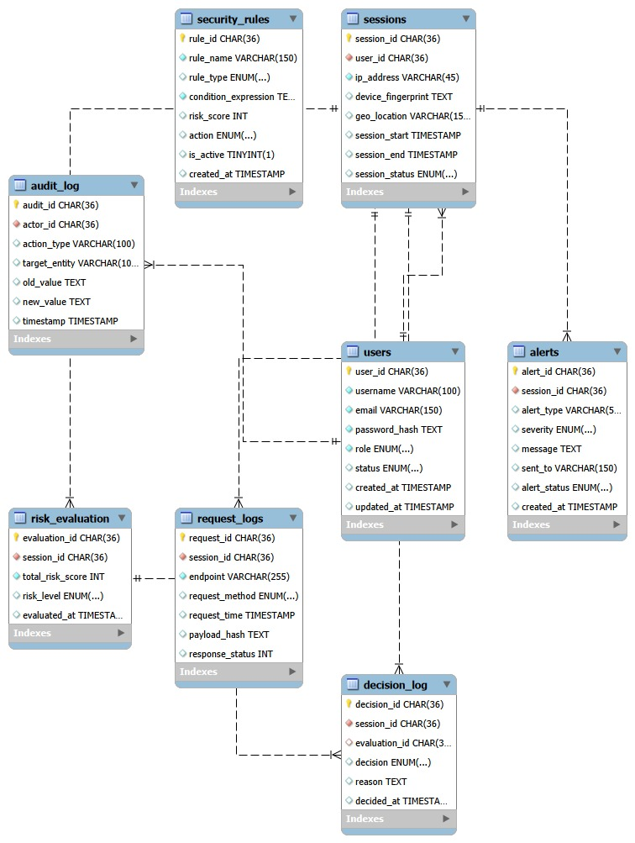

6.1 users
Stores registered user information.
Attributes:
- user_id (PK)
- username
- email
- password_hash
- role
- status
- created_at
- updated_at
Relationship:
- One user can have multiple sessions
6.2 sessions
Tracks active and historical sessions.
Attributes:
- session_id (PK)
- user_id (FK → users)
- ip_address
- device_fingerprint
- geo_location
- session_start
- session_end
- session_status
Relationship:
- One session belongs to one user
- One session can have multiple request logs
- One session can have multiple risk evaluations
- One session can generate multiple alerts
- One session can have multiple decisions

6.3 security_rules
Stores rule definitions used by Risk Engine.
Attributes:
- rule_id (PK)
- rule_name
- rule_type
- condition_expression
- risk_score
- action
- is_active
- created_at
Used by:
- Risk Engine during evaluation
6.4 request_logs
Logs each incoming request.
Attributes:
- request_id (PK)
- session_id (FK)
- endpoint
- request_method
- request_time
- payload_hash
- response_status
6.5 risk_evaluation
Stores calculated risk for each request/session event.
Attributes:
- evaluation_id (PK)
- session_id (FK)
- total_risk_score
- risk_level
- evaluated_at
6.6 decision_log
Stores decisions taken by Decision Engine.
Attributes:
- decision_id (PK)
- session_id (FK)
- evaluation_id (FK)
- decision
- reason
- decided_at
6.7 alerts
Stores security alerts generated for high-risk sessions.
Attributes:
- alert_id (PK)
- session_id (FK)
- alert_type
- severity
- message
- sent_to
- alert_status
- created_at
6.8 audit_log
Tracks administrative or system-level actions.
Attributes:
- audit_id (PK)
- actor_id
- action_type
- target_entity
- old_value
- new_value
- timestamp

7. Data Exchange Contract
7.1 Frequency of Exchanges
- Session validation → Every request
- Risk evaluation → Every validation
- Logging → Every request
- Alert generation → Only High/Critical risk
7.2 Data Sets Exchanged
Client → SIF:
- Session token
- IP address
- User-Agent
- Request payload
SIF → Backend:
- Verified request
- Authorization context
SIF → Security DB:
- Session metadata
- Risk score
- Decision
- Alert record
7.3 Mode of Exchange
Interaction | Mode
Client → SIF | HTTPS
SIF → Backend | Internal API Call
SIF → Security DB | SQL
Alerts | Email / Notification API

8. Deployment View
Nodes:
- Client Machine (Browser/API Client)
- Application Server (Hosting SIF Middleware)
- Backend Server (Business APIs)
- Security Database Server
- Application Database Server

9. Architectural Strengths
- Continuous session validation
- Real-time risk-based enforcement
- Separation of security and business data
- Modular and scalable design
- Audit-ready logging mechanism
- AI-ready risk engine

